**EXPERIMENT-4**

**Crypt-Arithmetic problem**

**AIM**:

To write and execute the python program for Crypt-Arithmetic problem.

**ALGORITHM:**

1. **Define Variables:**
   * Identify the distinct letters in the puzzle and assign them variables. For example, if you have a puzzle like "SEND + MORE = MONEY," assign variables to the letters S, E, N, D, M, O, R, Y.
2. **Generate Possible Assignments:**
   * Use a permutation algorithm to generate all possible assignments of digits to the variables, ensuring that each digit is assigned to a unique letter. You can start with a simple brute-force approach.
3. **Evaluate Constraints:**
   * Implement a function to check whether a given assignment satisfies the constraints of the puzzle. This involves substituting the assigned values into the puzzle equation and verifying that it holds true.
4. **Search for Solutions:**
   * Iterate through the generated assignments and use the constraint evaluation function to identify solutions to the puzzle. Keep track of valid solutions.
5. **Print or Output Solutions:**
   * Once solutions are found, print or output the values of the variables that satisfy the puzzle equation. If there are multiple solutions, you can choose to print all of them.

**Coding:**

import itertools

def get_value(word, substitution):

s = 0

factor = 1

for letter in reversed(word):

s += factor * substitution[letter]

factor *= 10

return s

def solve2(equation):

# split equation in left and right

left, right = equation.lower().replace(' ', '').split('=')

# split words in left part

left = left.split('+')

# create list of used letters

letters = set(right)

for word in left:

for letter in word:

letters.add(letter)

letters = list(letters)

digits = range(10)

for perm in itertools.permutations(digits, len(letters)):

sol = dict(zip(letters, perm))

if sum(get_value(word, sol) for word in left) == get_value(right, sol):

print(' + '.join(str(get_value(word, sol)) for word in left) + " = {} (mapping: {})".format(get_value(right, sol), sol))

if __name__ == '__main__':

solve2('SEND + MORE = MONEY')

**output:**

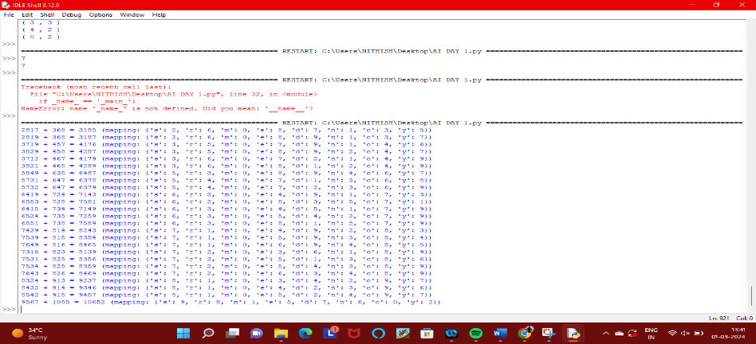

**Result:**

Thus the program has been successfully executed and verified.